**Executive Summary of CIGRE Women in Engineering Forum 2018**

Ruomei LI, Gen LI, Boya Qin

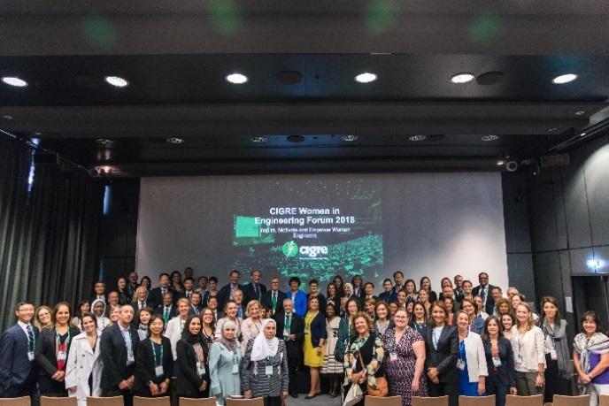The 3rd CIGRE Women in Engineering (WIE) Forum was successfully held on 30th August 2018 in Paris, France. “**Inspire, Motivate and Empower Women Engineers**” was the theme of this year. The event was organised by the WIE Taskforce led by **Ruomei LI** from CSEE and the CIGRE Central Office. More than 220 participants from power utilities, manufacturers and universities all over the world attended the event. There were not only female participants but also many male participants in the event. The forum consisted of five sessions: **Welcoming Address**, **Keynote Speech**, **Dialogue**, **Interactive Session** and **Interview**.

The event started with the welcoming addresses from **Rob STEPHEN** the CIGRE President, **Rovani SIGAMONEY** the UNESCO Engineering Programme Specialist, **Mark WALDRON** the CIGRE Vice President and Technical Committee Chairman and **John McDONALD** the IEEE PES Past President and CIGRE USNC Vice President. The moderator of this session was **Ruomei LI**.

There were four speakers in the Keynote Speech Session. **Philippe ADAM**, the CIGRE Secretary General, presented the “**Women members in CIGRE, Status, Challenges and Prospects**”. **Claire LAJO** **IE-MAZENC** from RTE, the Chair of French WIE, presented “**Why diversity is really needed in our very fast changing energy world?**”. **Carla DAMASCENO PEIXOTO**, UNOPS Consultant, presented “**Breaking Barriers with Energy**”. **Alaa Fawzi Al Kiyumi** from Oman Electricity Transmission Company presented “**Women’s growing leadership role in the GCC**”. **Khayakazi DIOKA** from ESKOM was the moderator of this session.

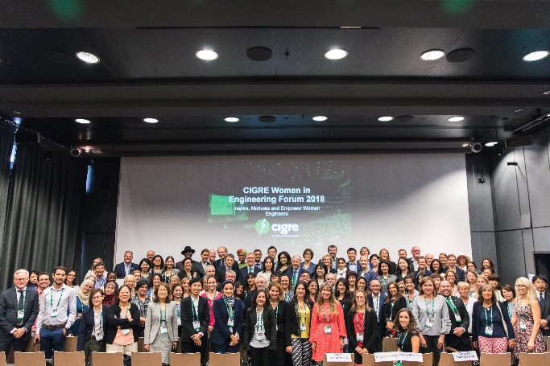The Dialogue session was host by **Marie HAYDEN** the Smart Wires Vice President. The theme of this session was “**How to promote Women’s function in CIGRE**”. **Michel AUGONNET** the CIGRE Vice President, **Britta BUCHHOLZ** the Vice President ABB Global Business Development, **Klaus KLEINEKORTE** the Board Member of Amprion GmbH and **Rannveig LØKEN** the Coming Chair for CIGRE SC B5 discussed several topics, such as “What can we do to increase the visibility of the many highly successful women in CIGRE?”, “What initiatives have worked in your company that you would encourage CIGRE to adopt? ”, “What is the role of the NCs and parent companies in all of this?”.

There were five young females in the Interactive Session. The topic of this session was “**Engineering in Women**”. **Amanda OLSON** from Burns & McDonnell talked “**Future challenges of engineering organizations**”. **Louise PREEDY** from OMNETRIC talked “Agile content generation @CIGRE--Advancement and Empowerment of Women Engineers”. **Tara-lee MACARTHUR** from ERGON talked “**Diversity and Inclusion Strategy**”. **Veronique BEGHIN** from Tractebel and **Claire CHEVALIER** from Siemens talked “**Challenges & Opportunities for Women in the new paradigm: Perspectives from Belgium**”. **Biljana STOJKOVSKA** from National Grid UK host this session.

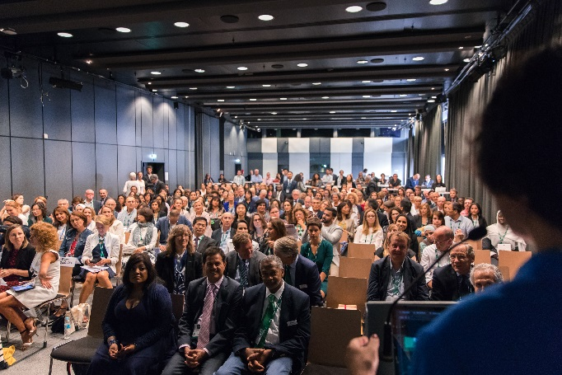Beyond the presentations and discussions from the speakers, there was an Interview Session for the people didn’t get the opportunity to share their stories and experience on the stage. The interviewees include, **Vera SILVA** the Chief Technology Officer from GE Power France, **Ahdab ELMORSHEDY** the President of Egyptian NC, **Tianshu BI** Professor from NCEPU China, **Gerd KJØLLE** Professor from NTNU Norway, **Sharon MUSHABE** the Chief Engineer of Line Engineering Services from Eskom South Africa, **Adam MIDDLETON** the Divisional Vice President Energy Management from Siemens and **Marcio SZECHTMAN** the coming CIGRE Technical Committee Chairman.

There were also two Networking sessions during the event. It provided a good opportunity for the speakers and participants to know each other and communicate.

Our role models showed their talent, leadership and capability in their work and life which made the WIE event very wonderful and successful. Many positive feedbacks about the event have been received from the speakers and participants. We believe that we can do better for women and for the future!

**Welcoming Address**

|  |  |
| --- | --- |
| D:\1 Office computer\My Ph.D at Cardiff University\Prof. LJ\tasks\2018 Prof. Ruomei Li CIGRE\WIE FINAL\WIE\Forum women in engineering\325A0280.jpg | The Chair of WIE2018, **Ruomei LI** made a brief introduction and opened the forum. |
| D:\1 Office computer\My Ph.D at Cardiff University\Prof. LJ\tasks\2018 Prof. Ruomei Li CIGRE\WIE FINAL\WIE\Forum women in engineering\325A0288.jpg | The CIGRE President, **Rob STEPHEN** made a brief introduction and opened the forum. He pointed out that, diversity has been regarded as an important issue in current situations, yet it is focused more on cultures and countries but less in gender. Gender diversity is essential. Women’s participation in working groups are gradually growing. He said the best thing about CIGRE is that we've got a global network. When we start WIE in one national committee, we can immediately get the network going into other national committees with other women in engineering. He believes the WIE event is critical, and hopes we can come to some solutions and suggestions on how to increase the momentum and get more diversity in our working groups, in order to make better products. |
| D:\1 Office computer\My Ph.D at Cardiff University\Prof. LJ\tasks\2018 Prof. Ruomei Li CIGRE\WIE FINAL\WIE\Forum women in engineering\325A0304.jpg | The UNESCO Engineering Programme Specialist, **Rovani SIGAMONEY** mentioned that there is a decline in university intakes in science and engineering with even fewer girls and women. Women are consistently underrepresented in engineering. She pointed out that, to ensure the attraction and retention of youth, especially young women in the STEM, we need to reflect on how science is brought to the classroom and at the age at which youngsters are introduced to science. UNESCO’s programme in Education for Sustainable Development (ESD) provides one possible example on doing this. AS the logo of our UNESCO-L’Oréal For Women in Science programme puts it, “The World needs Science, Science needs Women”. There is great potential in terms of brilliant, enthusiastic, young women who would make excellent future role-models and leaders in Science, Engineering and Technology. |
| D:\1 Office computer\My Ph.D at Cardiff University\Prof. LJ\tasks\2018 Prof. Ruomei Li CIGRE\WIE FINAL\WIE\Forum women in engineering\325A0335.jpg | The CIGRE Vice President and Technical Committee, **Mark WALDRON** mentioned that when the discussion about women in engineering started, we really need to think what to do. It is an issue about making absolutely sure everybody to have the opportunity to overcome the barriers and achieve the potential they have got.He suggested that we can do role-modelling, mentoring, and practical stuff to get people together to share experiences. He pointed out that about 25% committee chairs are women. They have the talent and the drive. They are in their positions because they are the right people for the job. There is still plenty of things like this to do, sharing, talking to people who have already succeeded in the organization. We are getting there. We are making progress. |
| D:\1 Office computer\My Ph.D at Cardiff University\Prof. LJ\tasks\2018 Prof. Ruomei Li CIGRE\WIE FINAL\WIE\Forum women in engineering\325A0356.jpg | The IEEE PES Past President and CIGRE USNC Vice President, **John McDONALD** mentioned that in GE they’ve started women’s network. Women form smaller groups and meet every month for lunch or learning sessions. He said it is important to have large group but also smaller groups that they can be more active. He believes that two things are important in encouraging women in engineering. The first thing is setting up female role models for female students so that they can see how someone can be successful. Mentoring and reverse-mentoring programs could be good examples. The second thing is to start getting students into engineering in high school ages.He shared his experiences that 6 years ago there’s a program in GE mentoring 40 high school boys and girls doing exploring programs for 9 months per year. He noticed that in some countries, the participation of women in engineering are much higher, Tunisia for example, 2/3 engineering students are women. In the end, he pointed out that in the next 5 years, 40% of employees and 60% of executives will be retired. So there’s a great opportunity for young females. |

**Keynote Speech**

|  |  |
| --- | --- |
| D:\1 Office computer\文档\photo\Phone\iPhone 020918\IMG_4388.JPG | **Khayakazi DIOKA** from ESKOM made a brief introduction of the four keynote speakers and host the keynote Speech session. |
| D:\1 Office computer\文档\photo\Phone\iPhone 020918\IMG_4392.JPG | **Philippe ADAM**, the CIGRE Secretary General, presented the “**Women members in CIGRE, Status, Challenges and Prospects**”. He compared the data of CIGRE women members in 2017 and 2018. It showed that the number of women members in different positions didn’t change too much in the last two years. More work needs to be done to make the CIGRE data base more reliable, especially the data from NCs. Central Office will continue to support the promotion of WIE initiatives. For instance, encourage WIE network in NC, host WIE forum during each CIGRE Session and publish more articles on national and regional WIE events through CIGRE media (Electra, website and newsletters). |
| D:\1 Office computer\文档\photo\Phone\iPhone 020918\IMG_4402.JPG | **Claire LAJO IE-MAZENC** from RTE, the Chair of French WIE, presented “**Why diversity is really needed in our very fast changing energy world?**”. She said that there is still very few female top manager or senior expert in engineering companies. More diversity is needed. The French WIE network is established to inspire women portraits, to coach students and to promote young female engineer. A more diversified electrical system will provide more creativity and innovation, better communication and social balance for both Women and Men. It will also give larger range of feelings and skills to find better solutions and achieve more efficiency for companies. At last, she said “**Let’s shape a better future Energy World all Together.**” |
| D:\1 Office computer\My Ph.D at Cardiff University\Prof. LJ\tasks\2018 Prof. Ruomei Li CIGRE\WIE FINAL\WIE\Forum women in engineering\325A0417.jpg | **Carla DAMASCENO PEIXOTO**, UNOPS Consultant, presented “**Breaking Barriers with Energy**”. She started with her personal story of her study, family and job. She enjoyed her life and work as an engineer. She talked the first WIE seminar in Brazil. She pointed out that women need to invest on continuous knowledge and transform challenge barriers into good opportunities to improve yourself. CIGRE could help as a source of exchanging knowledge from experts all around the world, good technical  documents with best practices and recommendations. At last, she said "**You cannot always jump the barriers. Sometimes go around them!**" |
| D:\1 Office computer\My Ph.D at Cardiff University\Prof. LJ\tasks\2018 Prof. Ruomei Li CIGRE\WIE FINAL\WIE\Forum women in engineering\325A0440.jpg | **Alaa Fawzi Al Kiyumi** from Oman Electricity Transmission Company presented “**Women’s growing leadership role in the GCC**”. She said that female is hesitant to study engineering due to various reasons: workplaces, environment, culture, intelligence and recruitment. She presented 6 Things Successful Women in STEM Have in Common: confident, claim credit for ideas, invest in peers network, build up protégés, be authentic and hone your brand. CIGRE and GCC CIGRE can play the role of helping female achieve these points. She also introduced the information about the GCC CIGRE where only 9% is female. At last, she said “**I believe great women and great men shall walk side by side with equal opportunities for a better future.**” |

**Dialogue Session**

|  |  |
| --- | --- |
| D:\1 Office computer\文档\photo\Phone\iPhone 020918\IMG_4461.JPG | D:\1 Office computer\文档\photo\Phone\iPhone 020918\IMG_4440.JPG |
| D:\1 Office computer\文档\photo\Phone\iPhone 020918\IMG_4447.JPG | D:\1 Office computer\文档\photo\Phone\iPhone 020918\IMG_4455.JPG |

**Interactive Session**

|  |  |
| --- | --- |
| D:\1 Office computer\文档\photo\Phone\iPhone 020918\IMG_4498.JPG | D:\1 Office computer\文档\photo\Phone\iPhone 020918\IMG_4530.JPG |
| D:\1 Office computer\文档\photo\Phone\iPhone 020918\IMG_4549.JPG | D:\1 Office computer\文档\photo\Phone\iPhone 020918\IMG_4553.JPG |

**Interview Session**

|  |  |
| --- | --- |
| D:\1 Office computer\文档\photo\Phone\iPhone 020918\IMG_4484.JPG | D:\1 Office computer\文档\photo\Phone\iPhone 020918\IMG_4488.JPG |
| D:\1 Office computer\文档\photo\Phone\iPhone 020918\IMG_4478.JPG |  |
|  | D:\1 Office computer\文档\photo\Phone\iPhone 020918\IMG_4578.JPG |
| **D:\1 Office computer\文档\photo\Phone\iPhone 020918\IMG_4495.JPG** |  |